Name_______________________________________________________________________________________________Period____________
ImageJ Photographic Analysis
Goal- Be able to quantitatively analyze your algae results by successfully using the ImageJ program.
Background- We have gotten the tough and gritty part out of the way: we’ve completed the algae experiment and observations! Now we need to analyze our results so we can come up with numbers that quantify the growth of our algae. We can assume that the growth of the Chlorella is directly proportional to how green the beaker is. This is called “proxy data.” (Proxy is another word for “puppet” or “substitute.” Proxy data are data that are not a direct measurement, but an indirect one.) You will learn to use ImageJ to perform this proxy analysis.
Starting Instructions-
- Before you do anything else, access the saved photographs of your algae, which you have labeled by date and experimental vs. control. Rename them so the date is clear, and whether the photo is the control or the experimental group. Example: 09.27 C and 09.27 E are good names for the control and experimental group for September 27. Save all of your algae photographs to your desktop so they are easy to access when using the software.
- Go to http://rsbweb.nih.gov/ij/download.html. On this page, find the section under “Windows.” Click on the blue link that says “Without Java.”
- Follow the download instructions, until a window appears that shows a folder called “ImageJ.” Open the folder.
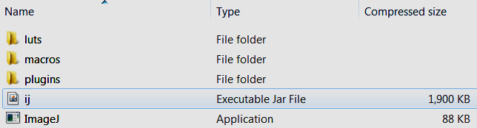
- In the folder, you will find an Executable Jar file called “ij.” I looks like this:

- Double-click on “ij.” (Note: It may take up to a minute for the program to appear. Also, save some time and copy-and-paste “ij” to your desktop. That way you can access it quickly as long as you are logged into your student account.)
- A narrow grey bar will appear. Welcome to ImageJ!
How to use ImageJ-
- Go to File, select Open, and open the first photograph of your algae.
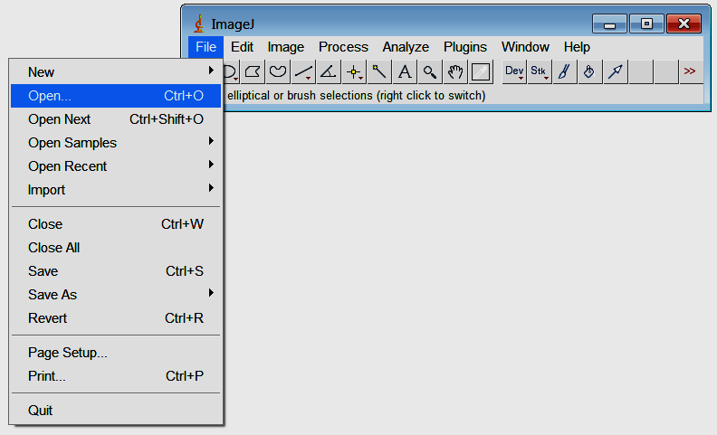
- When you open your photograph, a new photo window appears. Use the CIRCULAR CROPPING tool to select only the area of water that you are interested in: it contains algae.
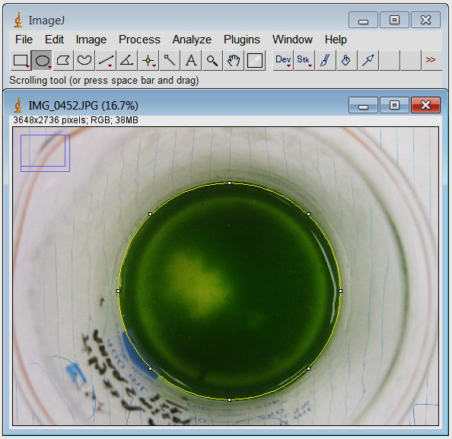
- At left I have selected the circular cropping tool and used it to drag a circle around the green part of the algae. You can adjust the circle by tugging on the tiny squares along its parameter. Only include parts of the picture that have algae.

- Now click on the tab that says “Analyze.”
- From the drop-down menu, select “Histogram.”

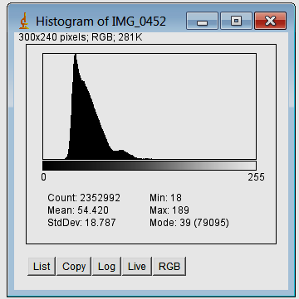
- Once you select “Histogram,” the image at right will appear.
- Click RGB (Red-Green-Blue) to cycle through the different color spectra. As you click RGB, it cycles you through Red, Green, then Blue spectra.
- Open your notebook. For each photograph, record the Mean of each color (except black), to the nearest tenth.
- As you record your data in your notebook, make sure you distinguish between each photo. Include labels, dates, Experimental vs. Control, etc.
- Now you are ready to analyze your data!

Analyzing ImageJ Data
- Refer to your data from ImageJ, which you have recorded in your notebook.
- Here is how you find out the percentage of green (and thus how much algae) for each photograph. Note: Please do all your work for ONE PHOTO, as an example. After that, you don’t have to show it.
  - Add the Means of Green, Red, and Blue (but not Black) for a photograph. Record this as the “Total Number Value.”
  - Now consider Green individually. Take the Mean for Green and divide it by the Total Number Value. It will be a decimal between 1 and 0.
  - Multiply this decimal by 100. The result is the percent of Green in that photograph!
  - Now subtract 33% from the number, since the fluorescent lights contribute exactly 1/3 of the green for all our photographs.
  - Record this number as “Percent Green” for that date and group (Control or Experimental).
- Perform this procedure for EVERY SINGLE PHOTOGRAPH! Later we will graph the data to show how the percent of Green (algae) has changed over time.
Graphing the Data
- Now you are ready to graph! Take your data and compile it into a table. Set up the table like so:
 | Date
Group | Day 2 | Day 4 | Day 7 | Day 9 | Day 11 | Day 14 | Day 16
Control
Experimental 1
Experimental 2
Only use Experimental 2 if you have two experimental groups.
- Only include the data for the percent of Green for each photograph. Now that your data is in a table, you can graph it.
- To graph your data, you need to put Time on the x-axis and Percent Green on the y-axis. Scale them appropriately.
- Use a multiple line graph, with each group (control vs. experimental) in a different color.
- Now you have graphed your data!
- Note: If you know how to use Excel, feel free to graph your data in that program. It automatically scales and graphs everything for you. If you want, I will show you how to use it.
Congratulations! Now you have a well-analyzed set of data you can use in your Results section. I look forward to looking at all your results and discussing them with you.

