Five years later, Deepwater Horizon spill damage still unfolding, says UGA's Samantha Joye

By LEE SHEARER updated Wednesday, April 22, 2015 - 6:19am
It’s been five years since the world’s largest accidental oil spill, but it will be many years before we know the full extent of the damage wrought by the Deepwater Horizon spill in the Gulf of Mexico, said University of Georgia marine scientist Samantha Joye.

Beginning on April 20, 2010, some 50,000 to 80,000 barrels of oil a day spewed from the well after the BP oil rig exploded and burned, killing 11 workers and injuring 16 others. By the end, something like 5 million barrels of oil had poured out, along with hundreds of thousands of tons of gas, mainly methane.

The disaster was in an area where Joye had already been conducting research, and members of her team were by chance on a research vessel near the blowout, becoming perhaps the earliest group to begin trying to answer fundamental questions such as what was happening to all that oil. They were also the first to spot and explore vast underwater plumes of oil that drifted away from the destroyed rig.

A month after the deep-sea well was finally capped, scientists said 75 percent of the oil was unaccounted for. Five years later, scientists have a better idea of where the oil went, but the fate of about 25 percent is unknown, Joye said.

A lot wound up on the ocean floor — sedimentation — said Joye, who’s been working on ways to figure out the fate of the oil and gas.

Bacteria consumed part of the oil and gas, though there was so much, they were overwhelmed by it. Joye was studying methane-eating microbes long before 2010, but no one had paid a lot of attention to microbes eating oil.

Some of the oil was burned, some was skimmed off the water surface, some evaporated, and a lot washed up onto Gulf Coast beaches or flowed into marshes, where some still remains.

“There were huge data gaps,” Joye said. “Now we’re beginning to fill some of those holes.”
Another unanswered question is whether the millions of gallons of chemical dispersants that BP poured on the light part of the oil that came to the surface did more harm than good.

But scientists are still handicapped by the lack of baseline data — measurements that would give clues as to what the affected area of the Gulf was like before the spill, so they could tell just how different it is now.

Before Deepwater Horizon, sedimentation wasn’t even part of the calculations for determining the fate of the oil.

“In fact, it’s really a critical part of that fate,” said Joye, who estimates conservatively that 10 to 15 percent of the oil wound up on the sea floor.

The sediment could have long-lasting effects that will amplify up the food chain as small creatures get eaten by larger ones, and they in turn are eaten.

Fishery catches have rebounded, but it’s too early to say that Gulf marine life has recovered, Joye said, because the fish that wind up in nets now had their beginnings before the spill. The impact on reproduction will show up in the next few years.

“We don’t have enough data to say what the long-term effects will be,” she said.

Joye was encouraged to see fish recently in some places deep on the ocean floor where life was gone after the spill.

But the spill took a big toll.

“The Gulf was already critically stressed,” she said, by things like the pollution-laden waters of the Mississippi River that create a huge low-oxygen “dead zone” in warm months.

At least scientists may be better prepared for the next big spill, though the next one could be much harder to contain. As oil wells deplete reserves closer to shore, oil companies have moved rigs into deeper and deeper water, where there’s more gas mixed with the oil, under much greater pressure from the weight of a mile or two of water.

The spill has changed Joye as well.

Joye was one of the leading independent scientists who challenged the low estimates of the spill’s magnitude put out by BP and the U.S. government at first, and stress took a toll.
Her courage and leadership have been recognized; she’s now a fellow of the prestigious American Academy for the Advancement of Science and the recipient of UGA’s 2015 SEC Faculty Achievement Award. Last year, a group of scientists she leads received a three-year, $18.8-million research grant.

The still-unfolding disaster has changed her personally, as well.

“It has made me very passionate about being an advocate for the ocean. I feel a tremendous responsibility to educate people,” she said.

It’s changed the way Joye and others do science, she said.

“We do it with a level of urgency and intensity, and this underlying feeling that the next one could happen tomorrow, so I need to do what I can do to get the community prepared,” she said.

It’s also made her keenly aware that “we’re all responsible for Deepwater Horizon,” said Joye, the mother of three children — we use the gasoline, consume the energy such wells pump out from beneath the ocean floor.

We’re all responsible for Deepwater Horizon, with our endless thirst for energy, and we’re responsible for shaping tomorrow’s world, she said.

“Everything I do is to make the world a better place for my children and their generation,” she said.

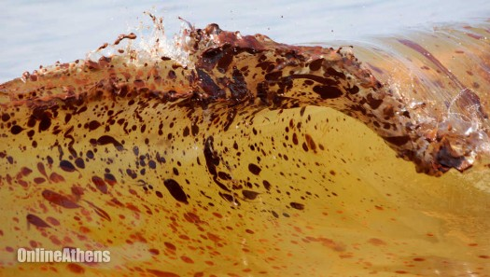
http://onlineathens.com/breaking-news/2015-04-22/five-years-later-deepwater-horizon-spill-damage-still-unfolding-says-ugas

