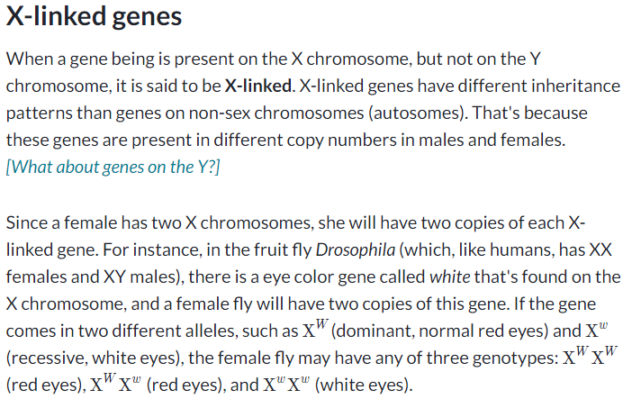
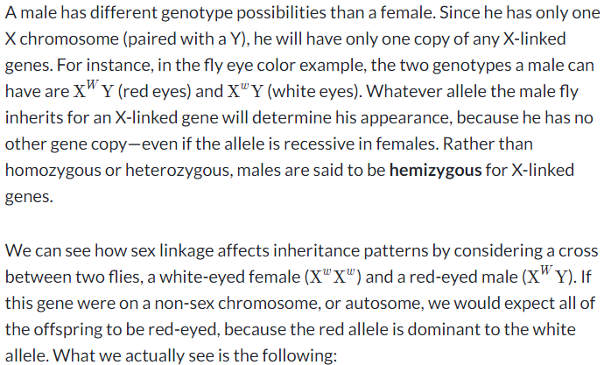
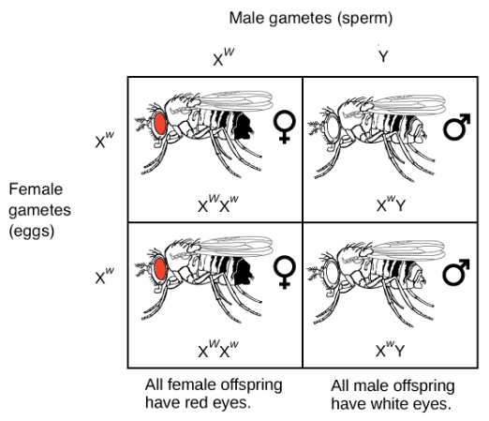
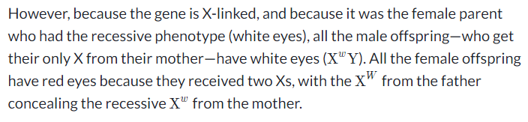
Adapted from https://www.khanacademy.org/science/biology/classical-genetics/sex-linkage-non-nuclear-chromosomal-mutations/a/sex-linkage-sex-determination-and-x-inactivation

